Energy
1

Know the law of the Conservation of energy
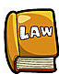
“Energy cannot be created or destroyed, only transferred from one place to another, or changed into other forms”.

Know the types of Energy
You need to know the eight main types of energy, and be able to give examples of each type:

Kinetic Energy (KE)
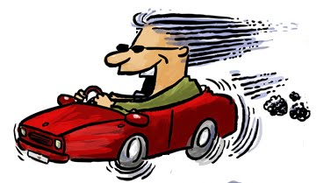
Objects have Kinetic Energy while they are moving.
● We transfer Kinetic Energy to an object to make it move.
● We transfer Kinetic Energy from the object to stop it moving.

Thermal Energy (heat)
All warm or hot objects have heat energy. Most energy transfers produce some heat energy, which is often not needed!

Sound Energy
Sound energy is carried as vibrations. The sound vibrations (or sound “waves”) can travel through air, water or many other materials.

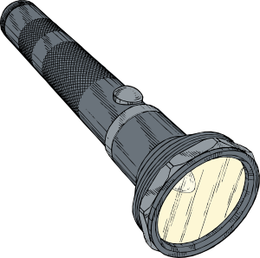
Light Energy
2
Lots of things produce light energy – like torches, fires, televisions, or the screen of your mobile phone! Most objects that produce light energy also produce some wasted heat energy.

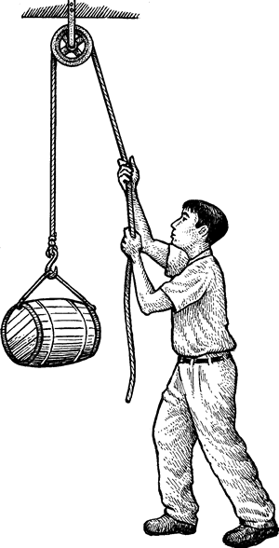
Gravitational Potential Energy (GPE)
Lifting an object takes energy because we do work against gravity. The energy is stored by the object as gravitational energy when it is raised off the ground. If the object is released the GPE is turned into kinetic energy – the object falls!

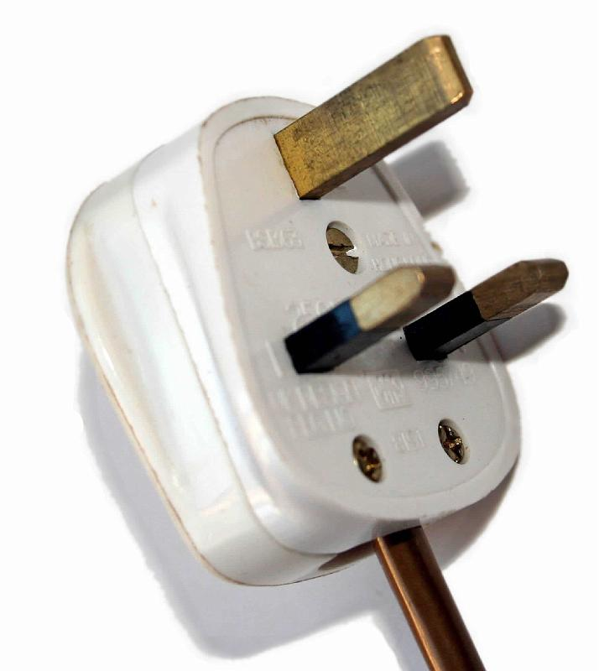
Electrical Energy
Electrical energy can be transmitted from place to place along wires. We can change it into many useful forms to power our devices.

Chemical Energy
Chemical energy is stored energy which can be released and used later. Batteries, coal and the food you eat are all stores of chemical energy.

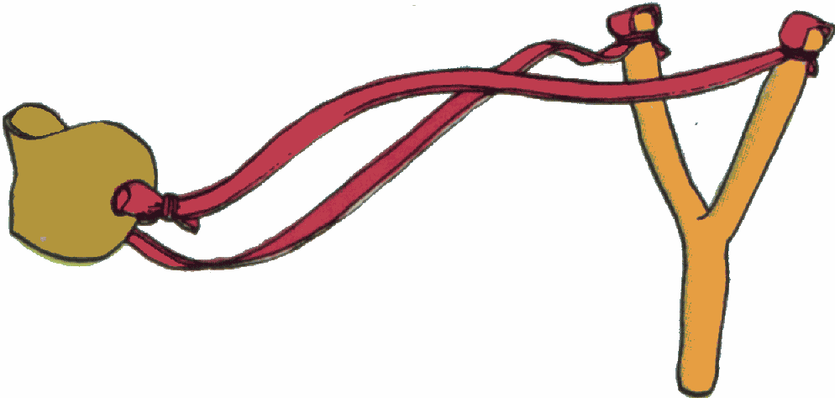

Strain Energy (a.k.a. “Elastic Potential energy” – EPE)
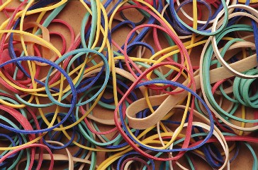
Strain energy is stored in objects which have been squashed or stretched, like stretched elastic bands, or squashed bouncy balls. The energy is released again – mostly as kinetic, when the object goes back to its unstretched state.

Energy transfer diagrams
3
We can show energy transfers using energy transfer diagrams.

Simple energy transfer diagrams only have one stage:
e.g. a television
electrical energy
light energy
heat energy
sound energy

Complex energy transfer diagrams have multiple stages:
e.g. a battery powered torch
electrical energy
light energy
chemical energy
heat energy

Energy Changes

transfer | When energy is moved from one place to another.  The energy will often change form.
wasted | Usually some energy is transferred into a form that is not needed – e.g. a lightbulb produces heat as well as light.
useful | The energy we wanted the device to produce – e.g. light from a lightbulb, or heat from a heater!
efficient | A device that does not waste much energy.

Speed
4

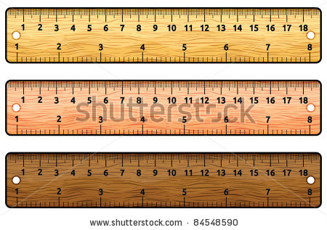
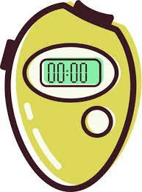
Know the quantities and standard units:

Distance is usually measured in metres (“m”)
Time is usually measured in seconds (“s”)
Speed is usually measured in metres per second (“m/s”)

Note: all letters must be lowercase!

Learn the equation and the equation triangle

You are not given the equation, or the equation triangle. You will need to learn them both!
×
S
t
D

Distance = Speed × time

Be able to convert quantities into standard units
You might need to convert quantities into standard units for more complex calculations. Do this before carrying out the calculation.

For example:
7km would need to be changed to 7000m
3 minutes would need to be changed to 180 seconds.

