Year 7 – Measuring voltage and current

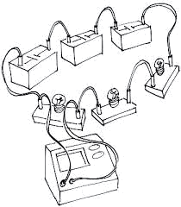
Build each of the circuits below and draw a circuit diagram to show how the components are connected together. Measure the current at each of the points specified and measure the voltage across the components specified. Record the values of voltage and current by each of your circuit diagrams.

1) One cell connected to one bulb. Measure the current in the circuit.

2) Two cells connected to one bulb. Measure the current in the circuit.

3) Two cells connected to two bulbs. Measure the current at 3 different points in the circuit. Label your diagram to show where you have measured the current.

4) Two cells connected to one bulb. Measure the voltage across the cells and across the bulb.

5) Two cells connected to one bulb and a 10Ω resistor. Measure the voltage across cells, bulb and resistor.

6) Three cells connected to two 10Ω resistors. Measure the voltage across the cells, and across each resistor.

Year 7 – Measuring voltage and current

Build each of the circuits below and draw a circuit diagram to show how the components are connected together. Measure the current at each of the points specified and measure the voltage across the components specified. Record the values of voltage and current by each of your circuit diagrams.

1) One cell connected to one bulb. Measure the current in the circuit.

2) Two cells connected to one bulb. Measure the current in the circuit.

3) Two cells connected to two bulbs. Measure the current at 3 different points in the circuit. Label your diagram to show where you have measured the current.

4) Two cells connected to one bulb. Measure the voltage across the cells and across the bulb.

5) Two cells connected to one bulb and a 10Ω resistor. Measure the voltage across cells, bulb and resistor.

6) Three cells connected to two 10Ω resistors. Measure the voltage across the cells, and across each resistor.

