Homework

Find out about a historically significant space mission, a forthcoming space mission, or a recent space mission. Write a brief description of the mission, including:

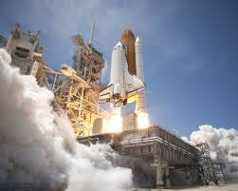
1) A picture of the spacecraft and/or satellite.
2) The purpose of the mission.
3) The date of the mission*.
4) Was it a manned or unmanned mission?
5) Where it travelled to, and whether it came back.
6) The size and weight of the payload or satellite it carried.

*or projected date, if it has not launched yet.

Homework

Find out about a historically significant space mission, a forthcoming space mission, or a recent space mission. Write a brief description of the mission, including:

1) A picture of the spacecraft and/or satellite.
2) The purpose of the mission.
3) The date of the mission*.
4) Was it a manned or unmanned mission?
5) Where it travelled to, and whether it came back.
6) The size and weight of the payload or satellite it carried.

*or projected date, if it has not launched yet.

Homework

Find out about a historically significant space mission, a forthcoming space mission, or a recent space mission. Write a brief description of the mission, including:

1) A picture of the spacecraft and/or satellite.
2) The purpose of the mission.
3) The date of the mission*.
4) Was it a manned or unmanned mission?
5) Where it travelled to, and whether it came back.
6) The size and weight of the payload or satellite it carried.

*or projected date, if it has not launched yet.

