pages
272
Circuit-breakers 1
Help
Sheet

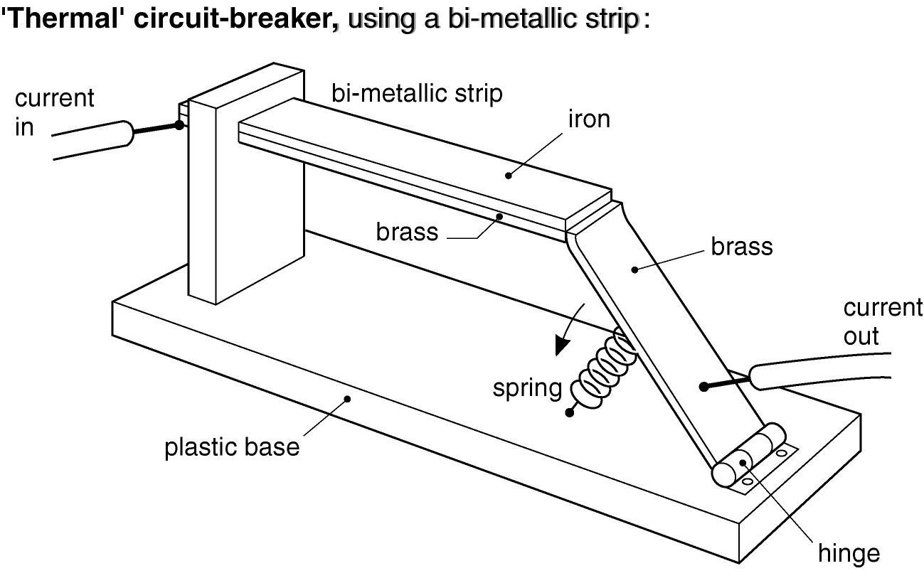

- Cut out and stick this diagram in your book.
You can make it clearer by adding colours as on page 272.
- Read page 23 (bi-metallic strip) and page 272 (circuit-breaker), and :
- Write a paragraph to explain how it works.
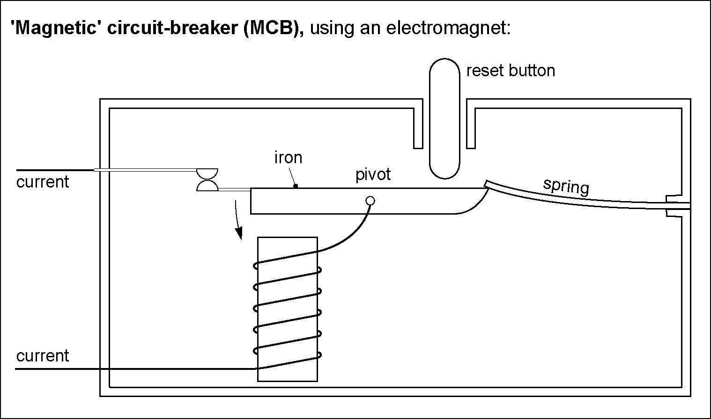

- Cut out and stick this diagram in your book.
You can make it clearer by adding colours as on page 372.
- Read page 372 (circuit-breaker), and :
- Write a paragraph to explain how it works.
- Read pages 268–269 (fuses, and the Earth wire), and :
- Explain the advantage of using an MCB rather than a fuse.

