Residual current circuit breaker (RCD)

The simplest kind of Magnetic Circuit-Breaker (MCB) uses an
electromagnet (see page 272).
If the current exceeds a certain value (usually 3 A, 13 A or 30 A)
the MCB breaks the circuit, like a fuse. However these currents
are too big for safety – they will easily electrocute you!

A more sensitive circuit-breaker is called an RCCB (Residual
Current Circuit-Breaker), also called an ELCB (Earth-Leakage
Circuit-Breaker), or an RCD (Residual Current Device).
This can switch off the current very quickly (in less than
30 milli-seconds) even if the fault current is as low as 30 mA.
It can stop you getting electrocuted.
You should always use an RCCB in any situation where you
could be electrocuted, eg. using an electric lawnmower.
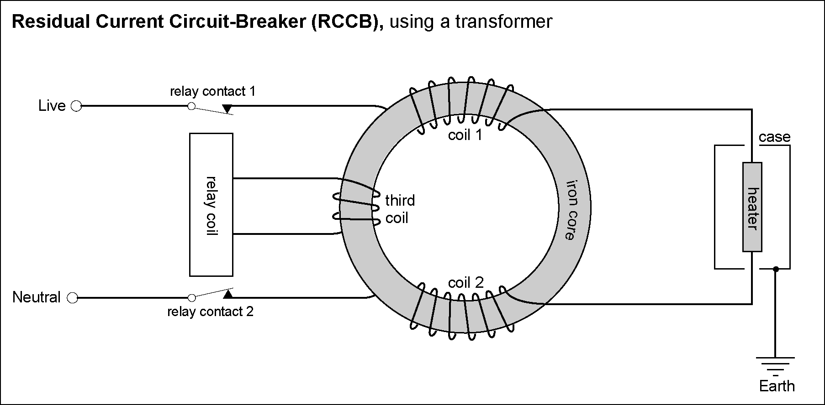

Complete the sentences:
This is how it works. The Live wire is wound round an _____ core (coil 1) and
after passing through the appliance (a ________) the Neutral wire is also wound
round the same iron ______ (coil 2).
i
h
c
c
There is the same number of turns on each ________ , but they are wound so that their
magnetic fields cancel out. There is no current in the third coil.

Suppose a fault develops, so that the Live wire touches the case of the heater
which is connected to E______ . The current in coil 1 is now _______ than the
current in coil 2. Now coil 1 and coil 2 do _____cancel out.
There will be an alternating _________ induced in the third coil, just like in a
transformer coil (page 302).
This current operates the relay (page 321), which opens both switches (relay contact 1
and relay __________ 2). The switches stay open and make the circuit safe.
n
m
c
c
Like other __________-breakers, it can be re-set when the fault is cured.
c

