Current Voltage graphs – data handling exercise

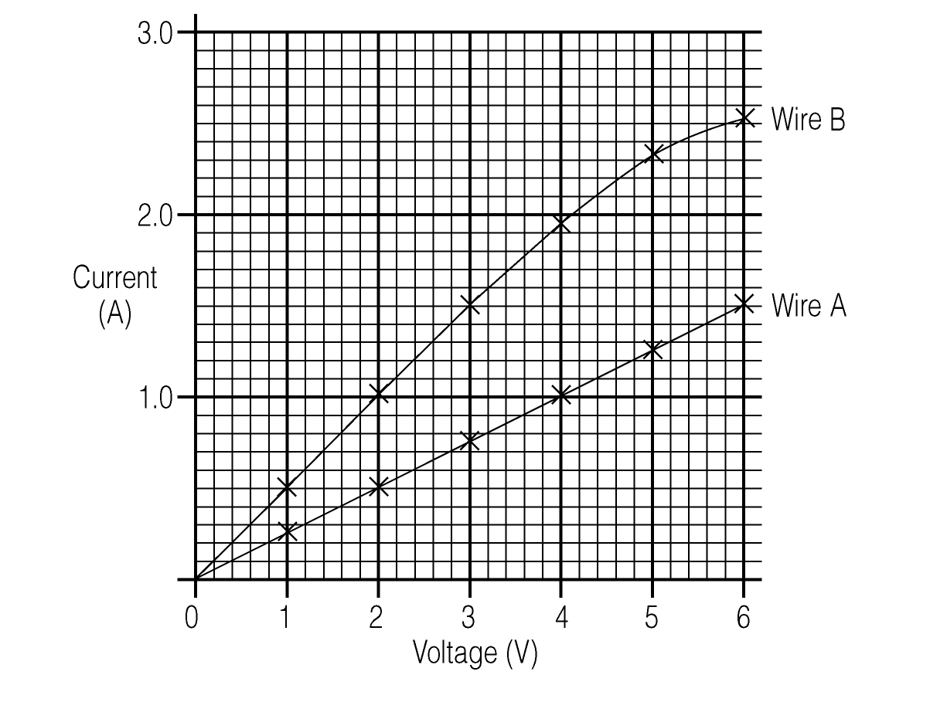

1. Using the graph, write down the current in wire A when the voltage across it is 3V.
2. Write down the current in wire B when 3V is put across it.
3. Which wire has the higher resistance ?
4. Complete this table for wire A:

Voltage  (volts) | Current  (amps) | $$\frac{\text{Voltage}}{\text{Current}}$$  (ohms)
2
3
4
5
6
5. What do you notice about your answers for $\frac{\text{voltage}}{\text{current}}$ ?
This value is the resistance of wire A, measured in ohms.
Wire B behaved slightly differently:
6. Draw up a similar table for wire B.
7. Describe what the table tells you.
8. Wire B got hot during the experiment. Why does this fact help to explain the results?

