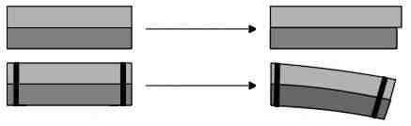
Metals expand when heated. Different metals expand at different rates.

If the bi-metallic strip (shown above) is heated the brass will expand more than the iron.

This will cause the strip to bend as shown.
brass
iron
Metals expand when heated. Different metals expand at different rates.

If the bi-metallic strip (shown above) is heated the brass will expand more than the iron.

This will cause the strip to bend as shown.
brass
iron
Metals expand when heated. Different metals expand at different rates.

If the bi-metallic strip (shown above) is heated the brass will expand more than the iron.

This will cause the strip to bend as shown.
brass
iron

