Impulse Questions

1.
Force/N
Time/s
1
3
5

A small rocket motor is fired and giving a force time graph as shown above.
a) What impulse is produced by the rocket?

b) The rocket is part of a satellite of mass 20 kg. What momentum change has the satellite?

c) What change in speed does the satellite have?

2. A 600 kg car is travelling at a steady speed crashes into a rigid wall. From the time when the car hits the wall the engine compartment is crushed so the main body of the car continues to move forwards. The graph shows how the retarding force on the main body of the car varies with time from the initial impact (t = 0 s)

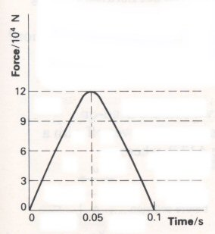
a) What impulse is required to stop the car?

b) By how much does the car’s momentum change during the impact?

c) Estimate the velocity of the car at the instant of impact.

Practical Advice
Two examples are given here so that worked examples are provided but they could be used as class questions.

Answers and Worked Solutions
1 a) Impulse = F x t = 5 x 2 = 10 N s
b) Change in momentum = impulse = 10 kg m s⁻¹. 0r 10 N s
c) mΔv = 10 so Δv = 10/20 = 0.5 m s⁻¹

2 a) The graph is roughly two triangles.
So the graph is effectively a rectangle 12 x 10⁴ x 0.05 = 6000 N s
b) Ft = mΔv so change in momentum is 6000 kg m s⁻¹
c) mΔv = 6000 so Δv = 6000/600 = 10 m s⁻¹ (approximately)

External References
Question 2 is taken from Revised Nuffield Advanced Physics Section A, question 52R

