by BPEARSON on FEBRUARY 4, 2010 · 0 COMMENTS
in LESSON PLANS, RESOURCES & TIPS, SCIENCE AT HOME

Ideas Covered
- The impulse* imparted to an object causes a change in its momentum*.
- Momentum is conserved in a closed system.
Materials:
- a set of happy sad balls
- wooden mallet
- eye screw hook about ¾” in diameter
- glue gun
- wooden block about 2” x 4” x 12” in size
- ring stand
- lattice clamp
- rod

Procedure:
- Cut the happy and sad ball in half.
- Screw the eye screw hook into the top of the handle of the wooden mallet so that the eyehook is parallel to the head of the mallet.
- Glue half of the happy ball on one end of the head of the mallet.
- The half the sad ball on the other end of the head of the mallet.
- Once the glue is dry, set up the apparatus as shown in the diagram below.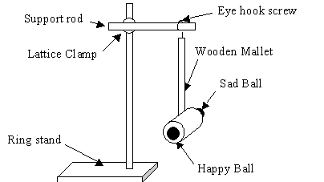

- Pull back the wooden mallet to a certain angle and always use that angle. About 30 to 45 degrees works best, but you may need to play with yours a little bit to see what works best for your set up.

- Set the wooden block standing up right in front of the wooden mallet, and adjust the distance from the wooden mallet to the block until the happy ball just barely is able to knock over the wooden block.
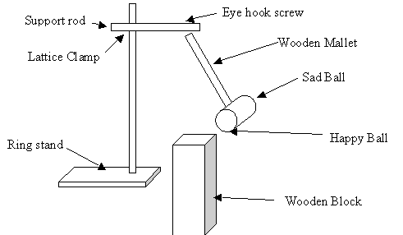

- You may want to mark were you positioned your wooden block and your apparatus, to make sure nothing moves.
- Now you are ready for the demo.
- Show your students the happy ball hitting the wooden block and knocking the block over, then flip the mallet around so that the sad ball hits the block this time. Show the students that you are releasing the other end of the mallet from the same angle as the happy side.
- This time the block will not tip over.
- Have your students come up with some reasons why this happens, you can have them hold the mallet and knock it against the table, they will see that the mallet will bounce from the table on the happy side and will not on the sad side.

Explanation:
Making some simplifications we can use the following calculations to show students the general idea of why the happy ball knocks the block over and the sad ball does not.
Assume that the speed that happy ball hits the block is the same as the speed that the ball bounces off at.
Assume that the speed of the sad ball after it hits the block is zero
J = impulse
p_{i} = initial momentum of the wooden mallet
p_{f} = final momentum of the wooden mallet
m = mass of the wooden mallet with the happy sad balls attached
v = the velocity of the mallet just before it hits the wooden block
J = Δp = p_{f}−p_{i}
For the happy ball:
J = mv – m(-v)
J = 2mv
* Since momentum is a vector quantity, the initial and final velocities in this case are equal in magnitude but opposite in direction. Therefore the initial velocity has a negative value since it goes in the opposite direction of the final velocity of the mallet.
For the sad ball:
J = mv – m(0)
J = mv
Therefore the impulse of the happy ball is twice that of the impulse of the sad ball. Impulse is force times time, so if we can assume that the time the happy and sad ball are in contact with the wooden block is the same, then we can assume that the average force acting on the block from the happy ball is twice the force applied by the sad ball.
The block is knocked over because there is more force acting on it from the happy ball than from the sad ball.
It is a good discussion for students to analyze how valid these assumptions are, but the simplifications make the math easy for students to understand at a high school level.
Reinforcement Activities:
You can tie many real life examples to this idea of impulse and momentum. For example, if a student was going to get into a car crash and they had a choice of hitting a snow bank or the side of a building, which should they aim for? You can also talk about Karate Chopping a board. If your hand doesn’t make it through the board it hurts more than if you break the board, have the students explain why that is. These questions would be good questions to introduce or follow up the topic.
Have students study conservation of momentum using a ballistic pendulum. Ballistics is used to study the speed of bullets coming out of a gun. This is an excellent example of using Physics in real life. Use a ballistic pendulum to simulate ballistics without firing weapons in your classroom.

