Mass and acceleration

- Which of these cars will accelerate at the greatest rate?
Explain your answer.
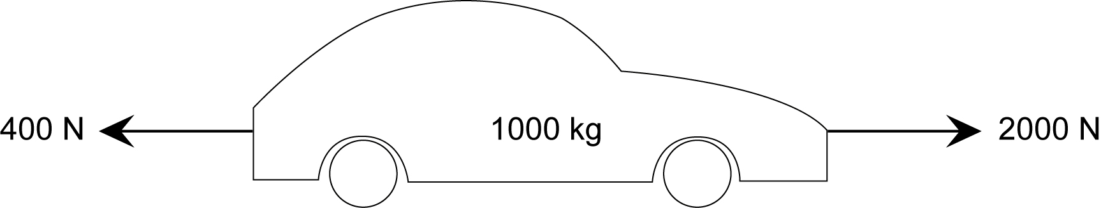
_____________________________________________________________________________________________________________________________________________________________________________________________________________________________________________________________________________________________________________

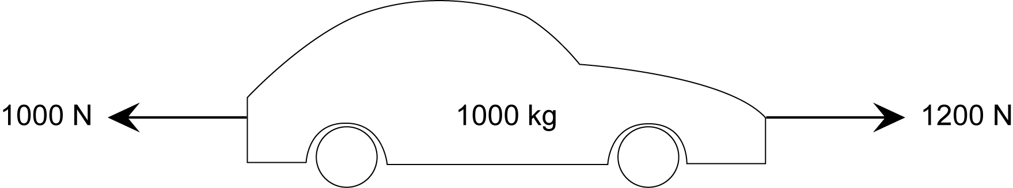

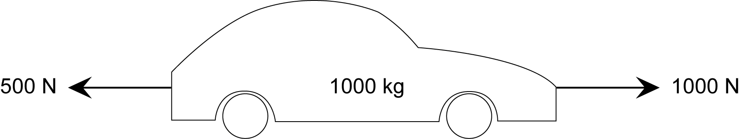

- Which of these will accelerate at the lowest rate?
_____________________________________________________________________________________________________________________________________________________________________________________________________________________________________________________________________________________________________________
Explain your answer.
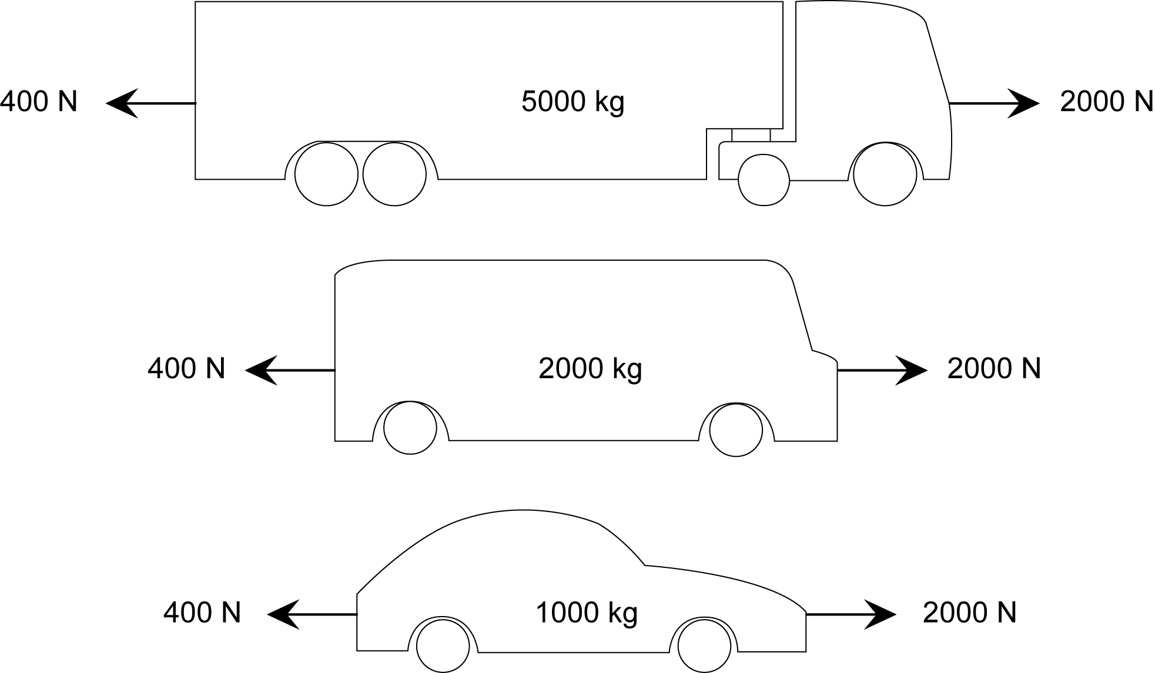

- Which of these will accelerate at the greatest rate?
Explain your answer.
_____________________________________________________________________________________________________________________________________________________________________________________________________________________________________________________________________________________________________________
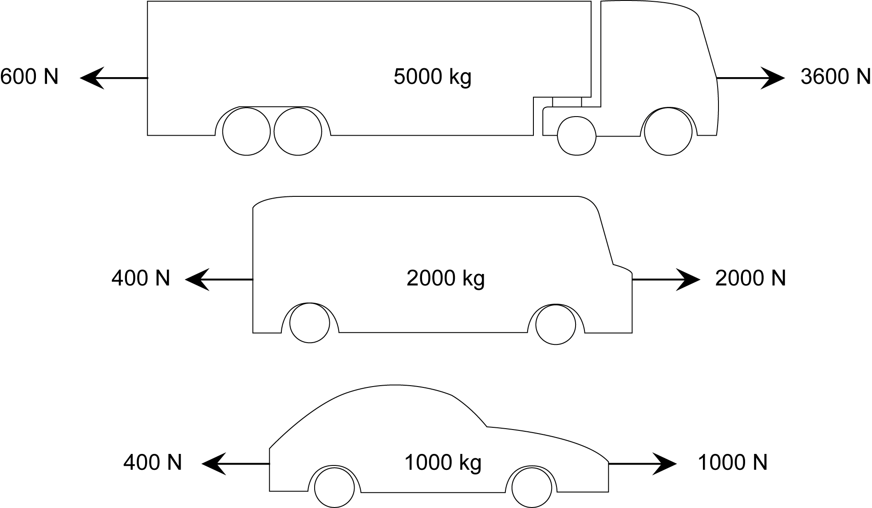

Using F = ma

