Coal-fired Power Stations

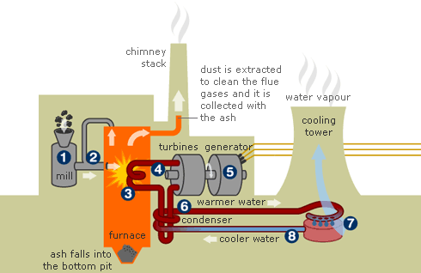
Electricity is made in huge quantities in Power Stations. The most common type of power station is powered by coal. The picture below shows the general idea.

----------------------------------------------------------------------------------------------------

1.) Cut out the sentences below, number them and put the in the correct order

It returns as cool water
The turbine turns a generator
The steam is cooled in a condenser
The coal is then blown in a stream of air
The steam turns a turbine
Coal is crushed in a mill.
It is burned in a large boiler
The waste heat is carried to the cooling tower

2) Draw a table with two columns and label the ‘Advantages of Coal’ and ‘Disadvantages of Coal’. Put the following statements in the correct column.

- They produce carbon dioxide which is involved in global warming
- They need trainloads of coal every day
- They do not produce dangerous waste
- They use coal which is relatively plentiful
- They are less expensive to build and run compared to nuclear power stations
- They produce sulphur dioxide which makes acid rain.

