Investigating Convection

Working in pairs set up a beaker, with two thermometers, as shown below.
Measure the temperature of the beaker at the top and bottom, every minute, and record your results in the table.

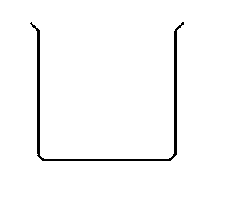
Digital thermometer
˚C

˚C
250ml beaker
200ml hot water
Time (mins) | Temperature at top (˚C) | Temperature at bottom (˚C)
0
1
2
3
4
5
6
7
8
9
10

Investigating Convection

Working in pairs set up a beaker, with two thermometers, as shown below.
Measure the temperature of the beaker at the top and bottom, every minute, and record your results in the table.

Digital thermometer
˚C

˚C
250ml beaker
200ml hot water
Time (mins) | Temperature at top (˚C) | Temperature at bottom (˚C)
0
1
2
3
4
5
6
7
8
9
10

