Changing the rate of transfer of heat energy

1. Write a list of all the things that can change the rate at which heat energy is transferred.

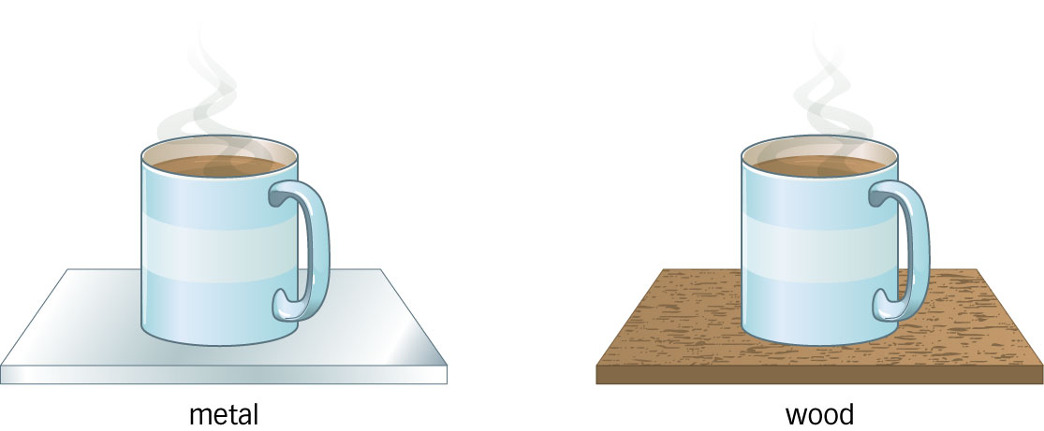
2. Explain how you could reduce the rate of heat energy transfer from a hot drink.

3. Which cup of coffee will cool down faster? Explain your answer.

4. What can you say about the rate of heat energy transfer in an object that is at the same temperature as its surroundings?

Changing the rate of transfer of heat energy

1. Write a list of all the things that can change the rate at which heat energy is transferred.

2. Explain how you could reduce the rate of heat energy transfer from a hot drink.

3. Which cup of coffee will cool down faster? Explain your answer.

4. What can you say about the rate of heat energy transfer in an object that is at the same temperature as its surroundings?

Changing the rate of transfer of heat energy

1. Write a list of all the things that can change the rate at which heat energy is transferred.

2. Explain how you could reduce the rate of heat energy transfer from a hot drink.

3. Which cup of coffee will cool down faster? Explain your answer.

4. What can you say about the rate of heat energy transfer in an object that is at the same temperature as its surroundings?

