Evaluating Energy Transfers

1.) How are the cape fox and the arctic fox adapted to their environment?

Are they trying to minimise or maximise the energy transfer to their surroundings?

What features help them to do this?
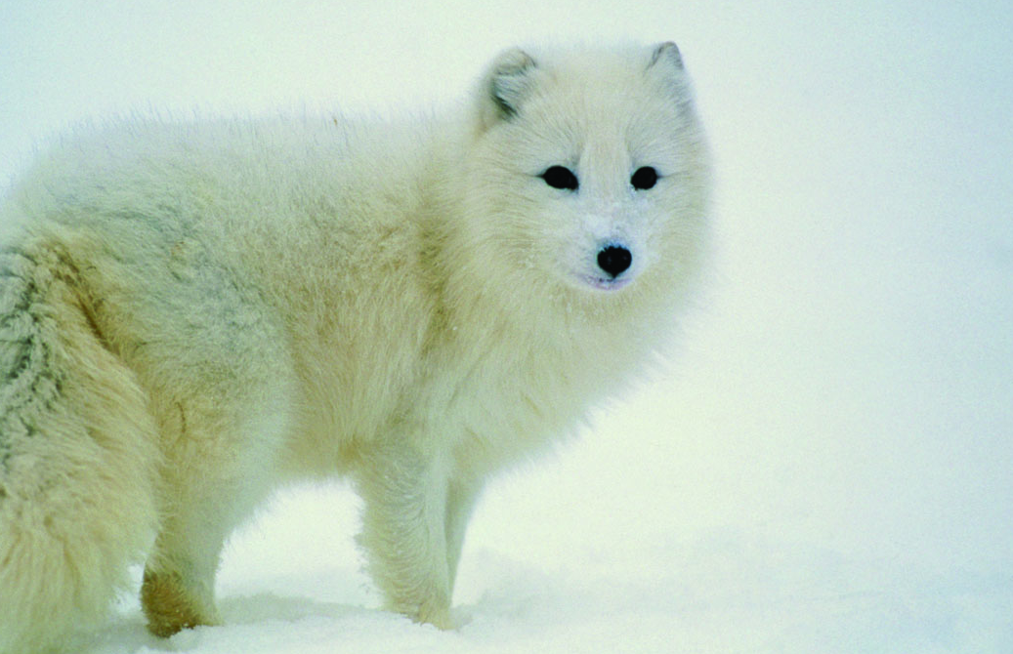
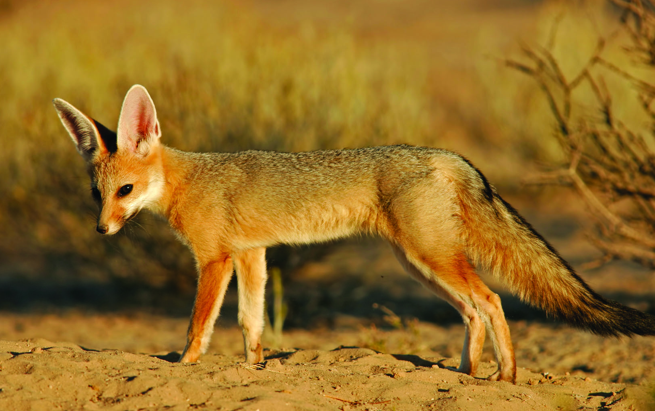

Cape Fox Arctic Fox

- Look at the list below. Which of these helps the human body maximise thermal energy transfer to its surroundings and which helps it to minimise thermal energy transfer. How does each process work?

  - Sweating
  - Hairs stand on end
  - Shivering
  - Reduced blood flow to the skin
Evaluating Energy Transfers

1.) How are the cape fox and the arctic fox adapted to their environment?

Are they trying to minimise or maximise the energy transfer to their surroundings?

What features help them to do this?

Cape Fox Arctic Fox

- Look at the list below. Which of these helps the human body maximise thermal energy transfer to its surroundings and which helps it to minimise thermal energy transfer. How does each process work?

  - Sweating
  - Hairs stand on end
  - Shivering
  - Reduced blood flow to the skin

