Comparing Energy Transfers

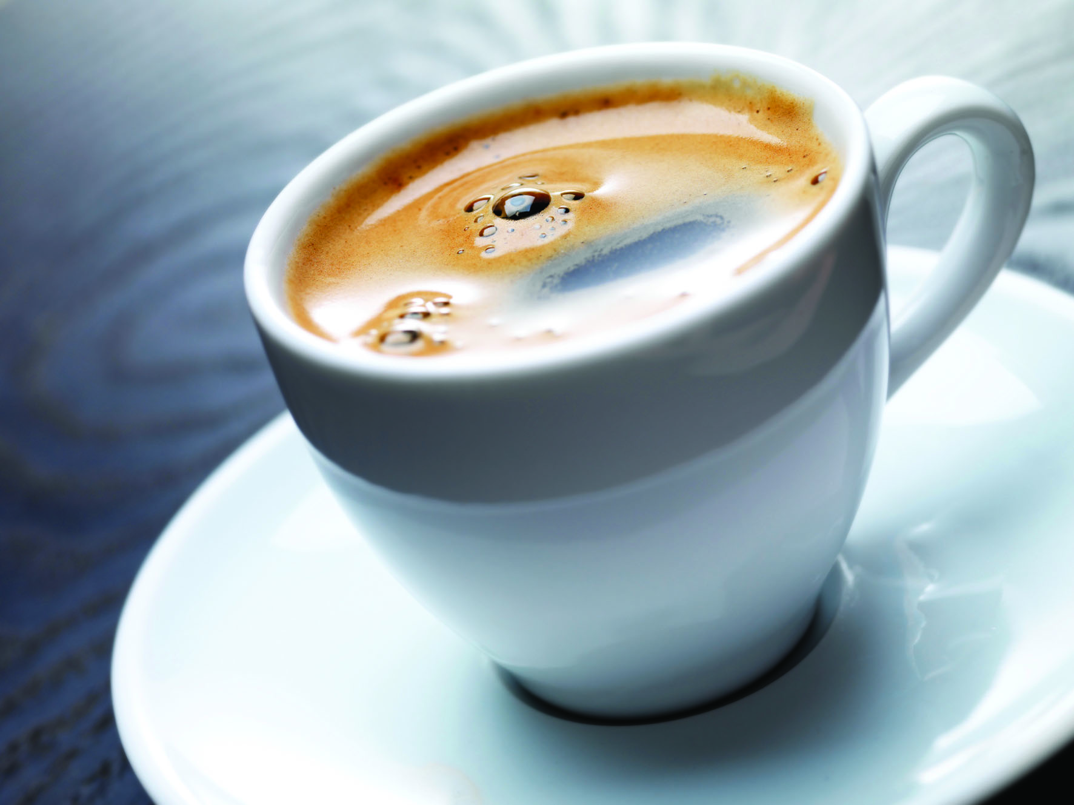
This hot drink contains energy. The hot drink will cool down because it is transferring energy to its surroundings.

Energy will be transferred until it reaches the same temperature as its surroundings.

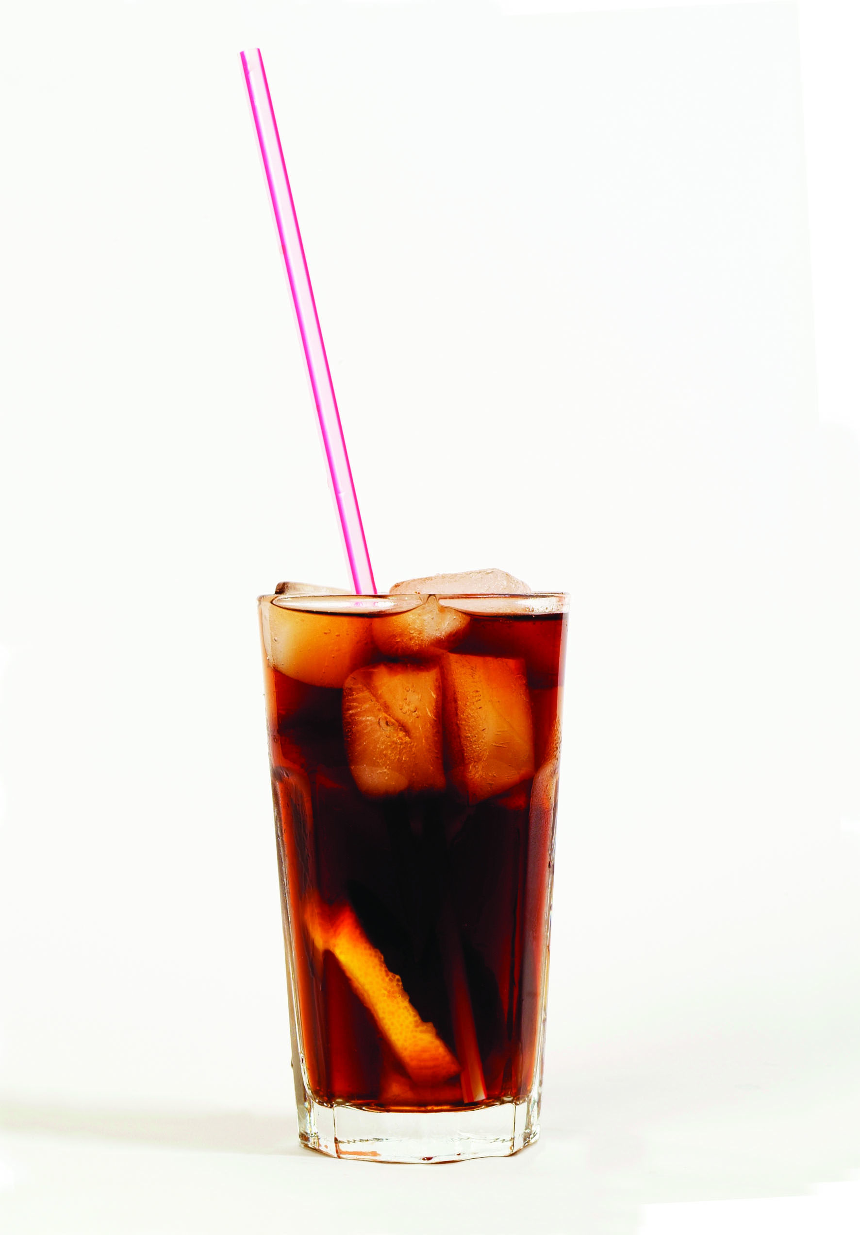

Now look at this cold drink. Is any energy being transferred here? Explain your answer.

_________________________________________________
_________________________________________________
_________________________________________________
_________________________________________________
_________________________________________________

You will find these rules useful when comparing energy transfers:

Energy is always transferred from warmer places to cooler places.

and

The greater the temperature difference, the faster energy is transferred.

