Evaporation
Try to explain each of the following scenarios using the correct technical language.
Stick this sheet in your exercise book and write the explanations alongside it.

Use as many of the following terms as you can in each of your explanations:

evaporation surface liquid energetic particles escape average thermal energy increase decrease temperature trapped rate cool

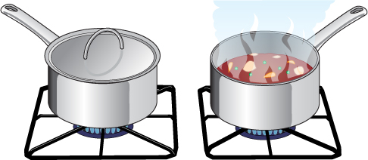
1. Look at these saucepans. How will evaporation affect how quickly the contents of the saucepans will heat up?

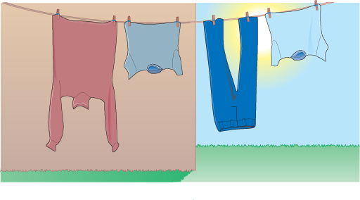
2. Look at these clothes on the washing line.
Which clothes will dry quickest and why?

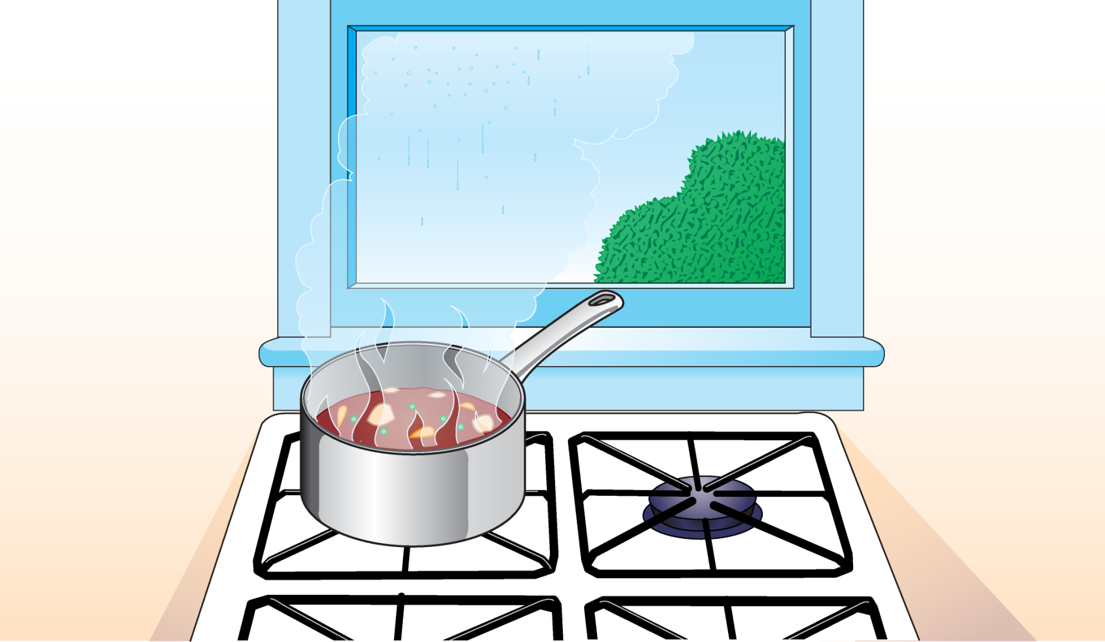

3. Look at the window behind this cooker. Can you explain why the glass is covered with condensation?

