Solids, Liquids and Gases

The diagrams below show how the particles are arranged for the different states of matter.
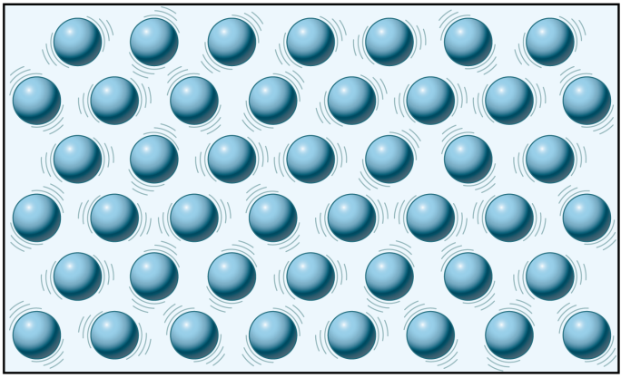
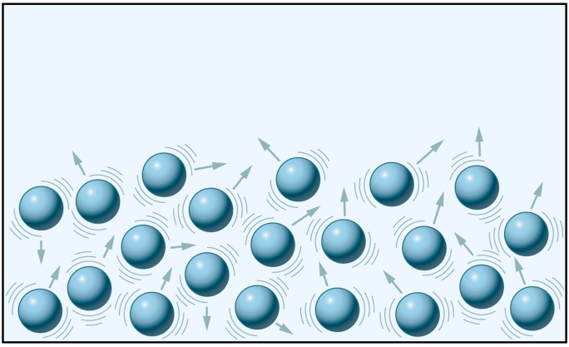
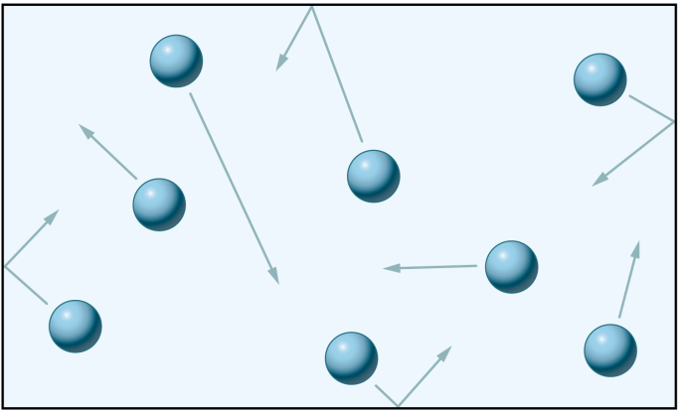

Solid Liquid Gas

Complete the table below using these words:
Very weak, Strong, Low, Weak, High, Moderate

 | Solid | Liquid | Gas
Force between the particles
Amount of energy

Solids, Liquids and Gases

The diagrams below show how the particles are arranged for the different states of matter.

Solid Liquid Gas

Complete the table below using these words:
Very weak, Strong, Low, Weak, High, Moderate

 | Solid | Liquid | Gas
Force between the particles
Amount of energy

