U Values

The U-value measures how well a building component, e.g. a wall, roof or a window, keeps heat inside a building. For those living in a warm climate the U-value is also relevant as it is an indicator of how long the inside of the building can be kept cold.

What is the U-value?
The U-value is a measure of the heat flow through a part of a building, as illustrated in the figures to the right. The higher the U-value the more heat flows through so a good U-value is a low one as you want to keep heat inside the building or outside depending on the climate you live in.

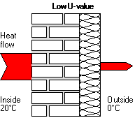
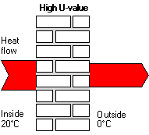

The technical explanation of the U-value (higher tier students – learn this definition!)
The U-value is the amount of energy lost per second, through 1 square meter of the building material, at a temperature difference of 1 Kelvin K (=1ºC).

The unit for U-values is W/(m²K).

For external walls, roofs, etc. a U-value of less than 0.2 W/(m²K) can be called good. This value can be reached by using thermal insulation with a thickness of about 20 cm or more. For windows the U-value should be less than 1.0 W/(m²K).

The simple rule:

Lower U-Values are better than higher U-Values

