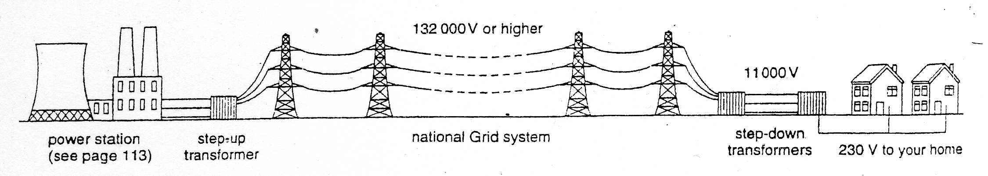
The National Grid

To transfer ______________________ from the _____________ station to my home, we could use either a low voltage and a high current, or a ________ voltage and a ________ current.

The first method is not efficient because the ___________ current heats the power lines and wastes a lot of _______________.

We use the second option instead. To get the high ____________ a step-up ______________ is used.

A

Electricity is supplied to my home at 230V
B

The turbine turns a generator
C

The voltage is increased to 132 kV or more by a transformer
I

The generator produces electricity
D

The energy is transferred through power cables at high voltage
E

Gas or coal or oil is burned in the power station
F

Water is heated to produce steam
H

The voltage is stepped-down to 230V by a transformer
G

The steam is used to spin turbines

